**Monographs and Coedited Books**

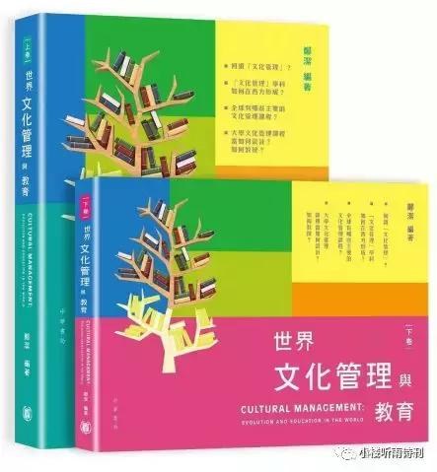

[clicking on the first book icon leads to this webpage:]

Zheng, J., *The Modernization of Chinese Art in Republican Shanghai: The Shanghai Art College*, 1913-1937 (Leuven Belgium: Leuven University Press).

( reviewed in Art and Design (December 2018)

reviewed in *Twentieth-first Century* (February 2018)

reviewed in *The China Quarterly* (December 2017)

reviewed in *The Journal of History of Education Society* (September 2917)

reviewed in *Taijiquan* (May 2016) )

Fist academic study on modernity at the Shanghai Art College The Shanghai Art College was one of the most important art schools in Republican China. This is the first academic study written on the early history of the College. It makes a major contribution to the history of art education in China, Shanghai in particular. The book presents a new approach to how people understand the modernization of Chinese art, and the significance and consequences of modernity in the Shanghai art world of the period 1913-1937. The author proposes new theoretical models to explain the interactions between multiple levels of social structures and artists, with a special emphasis on the role of art education institutions in transforming artists, artworks and the development of artistic fields. Presenting unique historical images hereto hidden in the archives of the College, the book brings forward the distinctive modern characteristics of the early 20th-century Shanghai Art College.

[clicking on the second book icon leads to this webpage:]

|  |
| --- |
| Zheng, J., 2016, *Shijie Wenhua Guangli jiqi Jiaoyu Wushinian* [Cultural Management: Evolution and Education in the World], vol.1, (Hong Kong: Chung Hwa Book Co.Ltd.) (in Chinese) |
| Zheng, J., 2016, *Shijie Fada Guojia yu Diqu Wenhua Guanli Kecheng Gailan* [World Geography of Cultural Management Education] (Hong Kong: Chung Hwa Book Co.Ltd.), vol.2 in the book series of *Cultural Management: Evolution and Education in the World* (in Chinese). |

The recent 20 years have witnessed a surge of arts and cultural management programs in China. Although the idea of “arts management” or “cultural management” originally came from Europe and America in the late 1980s, arts and cultural management education in China has its own definition and has grown on its own accord. A review of the Chinese cultural management literature shows that knowledge of cultural management education outside China is limited. To fill in the gap, this book is written to introduce the counterpart field in the West to serve Chinese cultural management educators. It is expected to enrich the Chinese literature on cultural management education. For China, experience from the West is crucial to prevent reinventing the wheel and to prepare educators in joining the international conversion on cultural management education. Research for this book project started in March 2016, and the data collection lasted for one year, and more than ten part-time research assistants participated in the data collection and translation. Furthermore, the writing and revision endured for one and a half year. The book was published by Chung Wah Book (Hong Kong) Limited Company in March 2019 [Fig.1, Fig.2].

        This book has the following seven research objectives:

* To synthesize and narrate how the arts and cultural management field evolved and to develop an understanding about the nature, characteristics, and boundary of the field through a systematic review of the English literature;
* To understand arts management, the core field of cultural management, on a number of issues, such as professional organizations, curriculum criteria, effectiveness of classroom teaching, key techniques, and academic research;
* To formulate a conceptual framework toward understanding creative industry management education;
* To identify cultural management programs in the developed world and compile them into a list;
* To carry out statistical comparisons of data across continents and countries, educational levels, and program focuses and to reveal a pattern of distribution and composition;
* To derive model curriculum structures from identified programs in arts management and cultural and creative industry fields; and
* To synthesize teaching pedagogies and display career paths of graduates.

https://managingculture.net/research/introducing-a-new-book-cultural-management-evolution-and-education-in-the-world/

[clicking on the third book icon leads to this webpage:]

Zheng, J., *Meishu Xuexiao yu Modeng Haishang Yishu Shijian: Shanghai Meizhuan, 1913-1937* [Art School and the Modern Shanghai Art World: The Shanghai Art College, 1913-1937], (Shanghai: Shanghai Bookstore Press). (in Chinese)

Book review: <http://www.cuhk.edu.hk/ics/21c/media/articles/c165-201710016.pdf>

[clicking on the fourth book icon leads to this webpage:]

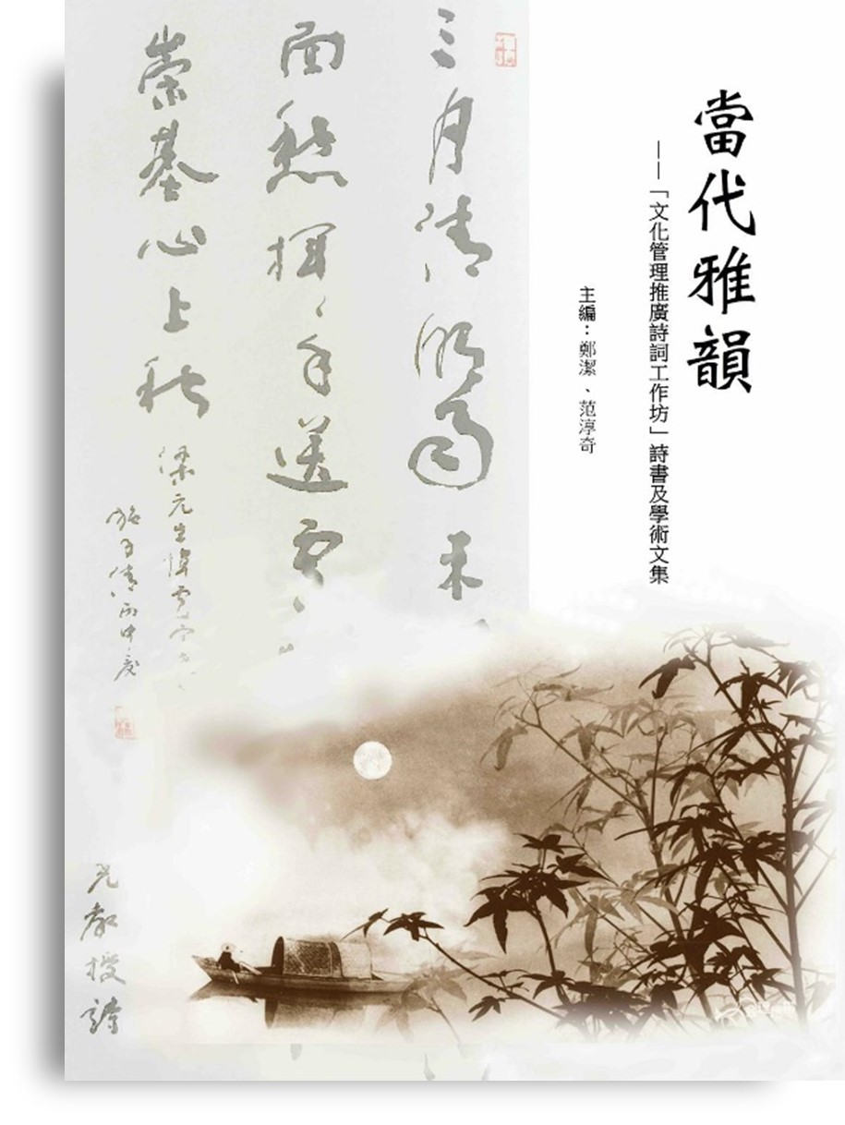

Zheng, J. and Fan C.Q., eds., 2016, *Dangdai Yayun: ‘Wenhua Guanyi Tuiguang Shici Gongzuofang’ Shishu Wenji* [Contemporary Elegant Rhythms: ‘The Cultural Management Approach to Promoting Classical Chinese Poetry Workshop’ Anthology], (Hong Kong: Calligraphy and Art Press).